**Self-Balancing Robot Research**  
**Dionne Wijayawickrama**

**Idea #1: Self Balancing Robot with High Torque**  
<https://youtu.be/fFwkQZr8wnQ>

[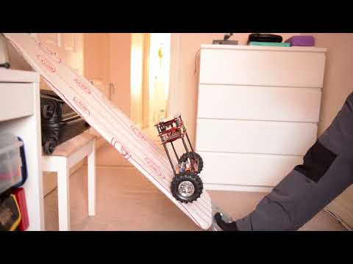](https://youtu.be/fFwkQZr8wnQ)

|  |  |
| --- | --- |
| 0:09 | 1:05 |
| 0:06 | 0:28 |

|  |  |
| --- | --- |
| How easily can you adapt the design to the VEX parts we have in the lab? | * We do have traction/omni wheels for this build and we have plates we could use for the platforms. * The video mentions a 30:1 and later a 50:1 gear ratio. The maximum that could be used on this project is 7:1 ratio with a red motor. Anything beyond that would be difficult to implement on a self-balancing robot as it would too much space to have a gear box and may cause unnecessary friction. Furthermore, it might put too much strain on the vex motor. * The traction wheels used in the video would be hard to implement as they are thicker and probably have better grip than vex traction wheels. * The platform design could be done with plates and c channels/standoffs. However, the plates can be easily damaged, which is especially not good for our event. Using C channels would need some precision to make sure the mass is balanced. Standoffs are not optimal as they become loose easily. One option could be standoffs with nuts as I found those to be secure. |
| Are all parts present in the images you found? | Yes, in the video, it is relatively easy to see all the major components of the robot. These include wheels and motor at the bottom connected to the first platform. The first platform has most likely power and the brain. The upper platform has sensors such as the distance along with more circuits. |
| Does your source demonstrate it working (how well suited it is)? | Yes, it works very well, and the creator shows it handles various tests well. These include   * Driving across rough ground such as gravel and lumps of grass with ease * Being able to climb up an incline (this mainly demonstrates grip rather than balance) * Even keep balanced as it goes up a ramp and the ramp breaks and it still stays on.   However we do not see how it responds to blows from the top which will happen to our robots during the match. We furthermore do not know how it will respond due to it’s mass distribution. It has a lot of mass at the bottom, nothing in the middle and some on the top. |
| Can it be built within the given time (4 hours)   * + - Testing/trouble shooting not included in this | It is a simple robot with not a lot of parts, it can easily be built in 4 hours/ 3 classes.  Firstly, the work can easily be divided amongst group members. Some can attach the motors to the first platform while another builds the upper platform. Then the two can be attached together. Afterwards it’s just wiring and addition additional sensors, etc. |
| Will you be able to program/control it? | Yes, it is programmable and controllable as it has a brain and we can control the wheels of the robot. |
| Is there sample code provided? | There is no sample code provided. However, the creator mentions how the robot runs on a PID control. Since we are given PID code in engage, we can definitely implement our knowledge to make a working code for the robot. |
| Does it use sensors? Do we have the sensors it uses? | *It uses sensors such as inertial and distance. We have these sensors and can code them. This model has a very good placement for the distance center and the top and if we make sure the robot is not to tall, it can be a good position. It could track other robots and have a clear view as seen in this model.* |
| Is the difficulty level appropriate | The main difficulty for the project would be the code, this is not a building heavy project other than making sure it was a good center of mass. Most of these robots are a good difficulty for our group. The design is easy to copy and implement on vex parts. The only main challenge is making sure it is stable and secure. To make sure it doesn’t break too easily. Most of the challenge is getting the code right, but it is pretty much the same regardless of design. The only thing that would need consideration is the immense torque when making the code. Modifications will need to be made there. |
| What strengths/weaknesses does the design provide for our goal(s)? | * The high gear ratio results in higher torque and more encoder counts per wheel revolution   + This will ultimately improve the speed control of the robot allowing it to have easier control of the speed and adjusting itself to the correct position. Should result in more stability as it has more control. * However, this robot has A LOT of torque. It might be too much for our design. Firstly, it might not be fast enough to recover from a blow. Secondly, those large gear ratios are most likely not sustainable or beneficial * Furthermore the platform design might to hard to build with the plates and standoffs/c channels. Plates are not that strong and easily bendable. Standoffs become lose easily unless lock tight is applied but it still poses a liability in my opinion. Applying c channels in the prototype is the main idea. * The design of the robot has an empty gap in the middle. This is liability for our event as it could result in a blow to the middle breaking or damaging the robot severely. Reinforcements would be needed. |

**Idea #2: Vex IQ Segway/Self Balancing Robot**  
<https://youtu.be/1P7SWxnKF_A>

[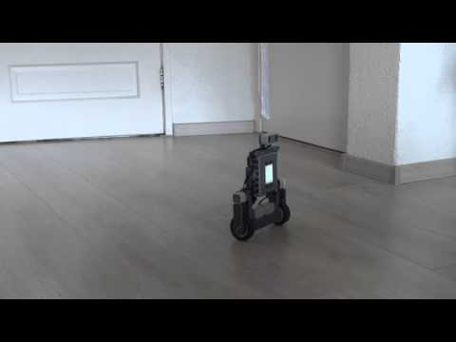](https://youtu.be/1P7SWxnKF_A)

|  |  |
| --- | --- |
| 0:13 | 0:05 |
| 0:18 | 0:25 |

|  |  |
| --- | --- |
| How easily can you adapt the design to the VEX parts we have in the lab? | * This design can be easily adapted to VEX V5 as the original robot was build in Vex IQ. The parts to share some similarities   + Most of these parts are smaller that vex V5 and lighter so adjustments will need to made there. For example the motors and brain are way smaller in this design opposed to vex v5 * A lot of these plastic segments will need to replaced with C channels. We will need to make sure the mass is even distributed. * The traction wheels we use are larger so we will need to make some space for that |
| Are all parts present in the images you found? | Yes in the video we get to see major components of the robot and most of the design build as the video shows a full rotation of the rotation of the bot. Furthermore the build instructions for this robot are here: <https://robotsquare.com/2016/04/06/tutorial-segway-iq/> |
| Does your source demonstrate it working (how well suited it is)? | It does show the bare minimum of this robot working as a self balancing robot, and being maneuverable and able to turn. However, we do not get to see two important things:   * The robot recovering from a blow or disturbances * The robot driving at faster speeds since right now, it is driving very slow.   Overall, the robot doesn’t look too stable and is very jittery at times. This is not suitable for our project. However, this is most likely an issue in the code rather than the overall design of the robot. If it’s using a PID control, I assume it’s Kp value might be set too high and would need some retuning. |
| Can it be built within the given time (4 hours)   * + - Testing/trouble shooting not included in this | Yes, it’s a simple robot design that can be built in 4hrs/ 3 classes if prototyped with Vex V5 parts beforehand. 1 person can work on the two motors and the other person will work on the top part. Then the two pieces can get attached along with brain and other sensors. |
| Will you be able to program/control it? | Yes, it is programmable and controllable as it has a brain and we can control the wheels of the robot. |
| Is there sample code provided? | The creator does show it can be programmable and it’s most likely controlled by a controller in the video. There is sample code found on their website. We can integrate some of this code into our own code for our own robot. <https://github.com/laurensvalk/segway> |
| Does it use sensors? Do we have the sensors it uses? | *The robot uses various sensors like the distance, inertial/gyro sensor. We have the Vex V5 counterparts of the sensors available to use. I believe the vex iq self-balancing robot uses a gyro sensor, but we can use an inertial sensor for our robot. Note: The sesnors in this design and the brain have no protection and a collision could result in damage, Modifications will need to be made.* |
| Is the difficulty level appropriate | In terms of building, robots are a good difficulty. It will require modifications and will take a little bit longer to build but can be done in 4 hours/ 3 classes. Once again, the main difficulty in the project is the coding aspect, which will remain the same regardless of design. We would have to spend most of our time testing and tuning the code to suit the robot. For building we’d need to make sure everything is stable and secure. Also, we need to make sure the mass is centered as an imbalance could result in robot tipping. |
| What strengths/weaknesses does the design provide for our goal(s)? | * The robot is symmetrical which makes it very balanced. I will try to implement symmetry in my prototype. * It is tall so it can collide with other bots unlike the smaller designs * The brain is very exposed so modifications like a protective plate on top will be necessary * This motor is most likely using normal motor and it has no gear ratio. This design has less torque than the other designs researched there   + Having speed is good since it can quickly adjust to errors   + However, lack of torque could result in less stability and control   + Furthermore the speed might not be strong enough to recover from some blows   + Finding a balance is necessary * The high torque motor results in higher torque and more encoder counts per wheel revolution   + This will ultimately improve the speed control of the robot allowing it to have easier control of the speed and adjusting itself to the correct position. Should result in more stability as it has more control.   + However too much toruqe might result in not enough speed to recover from blow, |

**Idea #3: Short Self Balancing Robot**  
<https://youtu.be/uJkf_v3BQmQ>

[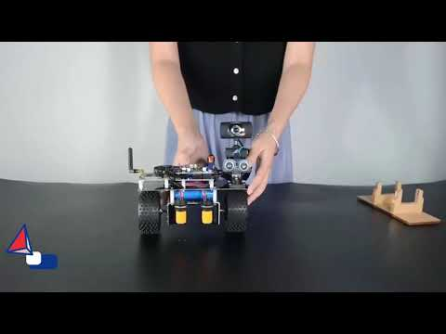](https://youtu.be/uJkf_v3BQmQ)

|  |  |
| --- | --- |
| 0:08 | 0:15 |
| 0:34 | 0:30 |

|  |  |
| --- | --- |
| How easily can you adapt the design to the VEX parts we have in the lab? | * We do have traction wheels, but they come in a different shape and have less traction. This will affect the spacing of the robot as additional space will be needed for the bigger wheels, changing the overall design. * We can build the platform that the robot uses using a base plate or normal plates. However, they are either too big or potentially too fragile. We would need to use other parts such as C channels to reinforce them. * The design uses a lot of standoffs. Although we have standoffs, they get loose easily unless some lock tight is applied. An alternative could be spacers and long screws. * Large torque stepper motor could be replaced with red motors, the motors in the video have batteries weighing the front down. Some considerations will need to make during prototyping |
| Are all parts present in the images you found? | Yes, in the video, it is relatively easy to see all the major components of the robot. These include wheels and motor at the bottom connected to the platform. They even list all the parts they used in the robot. They mention using a camera with a servo to record but that would not be needed for our design. |
| Does your source demonstrate it working (how well suited it is)? | Yes, it works very well, and the creator shows it handles various tests well. These include   * Being able to balance itself after a blow * Rotation * Being able to follow an object using a distance sensor * Balancing itself on a seesaw like structure. * Moving through an obstacle course showing it has good maneuverability |
| Can it be built within the given time (4 hours)   * + - Testing/trouble shooting not included in this | It is a simple robot with not a lot of parts, it can easily be built in 4 hours/ 3 classes. Furthermore, it is a very small and compact build, so it won’t take long to build. It can easily be built by 2 people within the given time. 1 person can work on the platform and add all the electrical/sensor components on it. The other person can build the drive base and then the two parts will be attached. |
| Will you be able to program/control it? | Yes, it is programmable and controllable as it has a brain and we can control the wheels of the robot. |
| Is there sample code provided? | There is no sample code provided. However the creator does show it can be programmable and shows it can be controlled by a controller. We are given knowledge on PID control and LQR control so we can definitely make our own code for the robot. |
| Does it use sensors? Do we have the sensors it uses? | *This robot uses various sensors such as distance, inertial and vision. These are the Arduino sensors and we the vex counterparts to use for this design. A vision sensor is not necessary for the event, and I doubt it could be practical. One idea could be for it to detect the opposing robot and charge at it, but that would be risky as we would have to reference off grey c channels and a lot of stuff is grey. It would most likely misidentify a wall for a robot and charge at it. It has a good placing of the distance sensor but it is very exposed. A blow could result in damage to the sensor.* |
| Is the difficulty level appropriate | In terms of building, I’d say it is on the easier side compared to other drivebases as it is small and simple. The main difficulty in the building process would be adapting the design to vex parts and making sure the center of mass is balanced. The main difficulty for the project would be the code, this is not a heavy building project. Most of the challenge is getting the code right, but it is pretty much the same regardless of design. There would be some modifications to the design such as adding protection to the sensors and brain and finding a good ratio or torque. |
| What strengths/weaknesses does the design provide for our goal(s)? | * The robot is very small, this could be beneficial as it is lighter and hopefully easier to balance   + However, since this is for sumo bots, the small size might not be beneficial. It cannot really attack the other bots and it can get overpowered by heavier bots * The high torque motor results in higher torque and more encoder counts per wheel revolution   + This will ultimately improve the speed control of the robot allowing it to have easier control of the speed and adjusting itself to the correct position. Should result in more stability as it has more control.   + However too much toruqe might result in not enough speed to recover from blow, * Furthermore the platform design might to hard to build with the plates and standoffs/c channels. Plates are not that strong and easily bendable. Standoffs become lose easily unless lock tight is applied but it still poses a liability in my opinion. Applying c channels in the prototype is the main idea. * The brain and sensors are exposed. Any collisions from the bots during the sumo tournament could damage them. Modifications like an upper platform will need to make to protect the parts. |

**Idea #4: Tall Self Balancing Robot- Arduino**  
<https://www.youtube.com/watch?v=9W5S5nqRegU&pp=ygUYc2VsZiBiYWxhbmNpbmcgcm9ib3QgdmV4>

[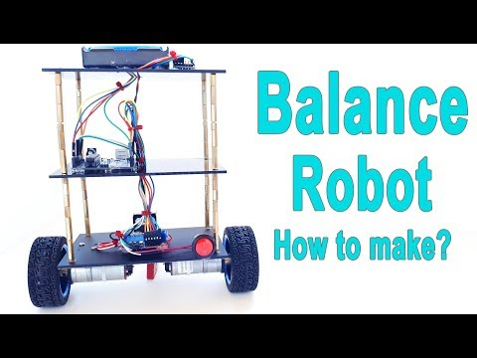](https://www.youtube.com/watch?v=9W5S5nqRegU&pp=ygUYc2VsZiBiYWxhbmNpbmcgcm9ib3QgdmV4)

|  |  |
| --- | --- |
| 0:53 | 0:22 |
| 0:39 | 3:37 |

|  |  |
| --- | --- |
| How easily can you adapt the design to the VEX parts we have in the lab? | * We can build the platform that the robot uses using a base plate or normal plates. However, they are either too big or potentially too fragile. We would need to use other parts such as C channels to reinforce them. * We do have traction wheels, but they come in a different shape and have less traction. This will affect the spacing of the robot as additional space will be needed for the bigger wheels, changing the overall design. * The design uses A LOT of standoffs. Although we have standoffs, they get loose easily unless some lock tight is applied. An alternative could be C channels instead. |
| Are all parts present in the images you found? | Yes, in the video, it is relatively easy to see all the major components of the robot. In fact, all the parts are provided in one of the frames I screenshotted. There is also a brief tutorial on the assembly of the robot. |
| Does your source demonstrate it working (how well suited it is)? | Yes, it demonstrates the robot doing various tasks such as:   * Balancing after being pushed(slightly tapped) * Driving over a bump * Some ability to rotate * The ability to follow using distance sensor   However, the robot is a little bit jittery and unstable at times. This is more of a coding issue than physical though. Furthermore, we don’t see it recovering from a bigger blow that would happen in our event. |
| Can it be built within the given time (4 hours)   * + - Testing/trouble shooting not included in this | With a vex prototype, it can be built in 4 hours/ 3 classes. Some design specifications are provided in the video like the height. One person would work on the motor and the first platform while the other person works on the upper platforms. Then they can be connected at the end. |
| Will you be able to program/control it? | Yes, it is programmable and controllable as it has a brain, and we can control the wheels of the robot. |
| Is there sample code provided? | Sample code is provided here <https://create.arduino.cc/editor/mertarduinotech/82996666-236e-4ead-8df2-f34fb709c5b5/preview>  Even though it is using Arduino libraries, we can integrate it into our vex code. Furthermore, the go into detail about the coding process in the video. This code is a PID control. |
| Does it use sensors? Do we have the sensors it uses? | *This robot uses various sensors such as distance and inertial. These are the Arduino sensors and we the vex counterparts to use for this design.* |
| Is the difficulty level appropriate | It is not difficult to build as we have all the parts needed and the process. All that is needed is a vex prototype and it can be done quickly.   The main difficulty in the building process would be adapting the design to vex parts and making sure the center of mass is balanced. One again, this is more of a code heavy project. The coding difficulty is roughly the same for all designs. However in this one, the code is provided in all the K values for PID control. This will make it easier than some of the other designs because of this since we have some values to start with. |
| What strengths/weaknesses does the design provide for our goal(s)? | * The mass is even distributed with a bit more on the top, this could make it more easy to control. * The platforms seem good but they might be susceptible to damage if the standoffs are hit by another robot. Replacement with c channels might be better for more structure and stability. * The robot did look a bit unstable at times, so either code should be adjusted or more torque should be added   + This will ultimately improve the speed control of the robot allowing it to have easier control of the speed and adjusting itself to the correct position. Should result in more stability as it has more control.   + However too much torque might result in not enough speed to recover from a blow, * Furthermore the platform design might to hard to build with the plates and standoffs/c channels. Plates are not that strong and easily bendable. Standoffs become lose easily unless lock tight is applied but it still poses a liability in my opinion. Applying c channels in the prototype is the main idea. * The brain and sensors and less exposed since the are in the platforms, some additional protection for the brain may be needed. |

**Other Resources:**  
<https://youtu.be/OLq3eRUZ-38>

[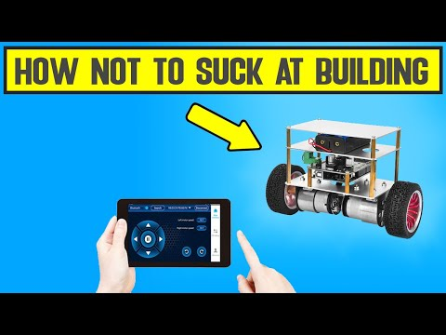](https://youtu.be/OLq3eRUZ-38)

<https://youtu.be/vPx2oyZGv50>

[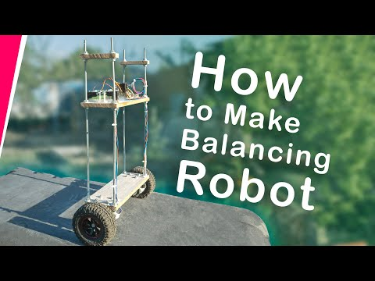](https://youtu.be/vPx2oyZGv50)

<https://youtu.be/EEnSDy4PouE>

[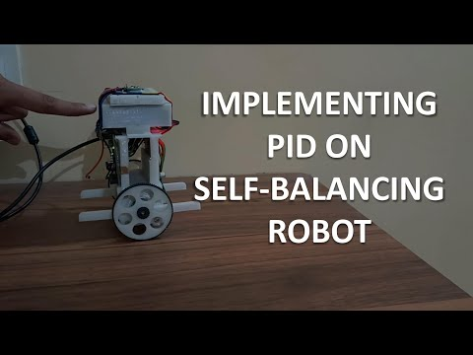](https://youtu.be/EEnSDy4PouE)

[Control Tutorials for MATLAB and Simulink - Inverted Pendulum: System Modeling (umich.edu)](https://ctms.engin.umich.edu/CTMS/index.php?example=InvertedPendulum&section=SystemModeling)

[Inverted pendulum - Wikipedia](https://en.wikipedia.org/wiki/Inverted_pendulum#External_links)

[What Is Torque? - Definition, Formula, Symbol, Unit, Examples (byjus.com)](https://byjus.com/physics/torque/#:~:text=Torque%20is%20the%20measure%20of,rotational%20equivalent%20of%20linear%20force)